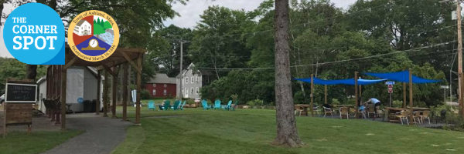
The Corner Spot “Shop on the Spot”, “Pop-Up”
and Event Application
The Corner Spot is a “pop-up” park and storefront in downtown Ashland where businesses can test-drive the market and residents can gather. The Corner Spot is intended to stimulate economic activity, attract and support new and existing business, and make the downtown more vibrant. The Corner Spot is located at 6 Cherry Street and serves as the home for new businesses to "pop up" in the shed allowing residents to enjoy a variety of potential additions to the Ashland business community. It is a place for people to gather for a wide array of events including food, music, performers and more.
The Corner Spot offers outdoor seating, tables and chairs, a children’s play area, porch swings and a free mini library. The businesses that “pop-up” in the 300 square foot storefront have the opportunity to run their business based on their business plan and schedule to “test” out their success with the hopes of finding permanent space in Ashland. The Corner Spot serves as a resource for any business owner testing the market in a downtown setting, regardless of the business’ phase or size. In addition to the shed the space lends itself to wonderful events with pop up option for your business. Shop on the Spot Event is a great opportunity to join other businesses at the #bestspotintown to introduce your brand and experience Ashland. Join other small businesses in a pop up park setting to sell goods, market your business and meet new people. These events are paired with food and music and marketed to the community and the region.
To join in Pop Up Events, please answer the following:

What are you planning? (Circle all that apply)
- One Day event
- One Day Pop Up
- Shop on the Spot

The Corner Spot provides free wifi, outdoor power source, restrooms. If you are looking to utilize the shed for your one day event please notify us to check availability.

I. Business Name/Organization and Description:

II. List your social media site(s) with your account/handle(s).
Example: Instagram @thecornerspotashland

III. Please list the one day pop up or event date and time you are requesting.
IV. “Shop on the Spot” dates are listed below. Circle the dates to confirm your participation on the following Fridays from 5- 7 pm.
June 10th (in conjunction with a LGBTQIA2S+ Pride Event)
June 24th
July 8th
July 22nd
August 12th
Saturday, August 27th (Women Business Owners Only Signature Event)
V. List your operating needs (electricity, Wi-Fi, etc.).

VI. List the equipment you are bringing.

VII. If you are planning an event please describe the day.
Additional Requirements
- Must provide your own tent and table(s)
- Must comply with all permits, including Board of Health requirements, permitting, and fees
- Everything must be removed and must be left the same way it was found.

Shop on the Spot Event Cost:
- $25.00 per pop-up day.
  - To participate in all six Shop on the Spot event days the total is $125.00 ($25 discount)
  - Please submit a check to:
The Town of Ashland
101 Main Street. Ashland, MA. 01721
Memo: The Corner Spot
Submit Application to Ashley Place at aplace@ashlandmass.com
For questions, contact Ashley Place at 508-532-7935

