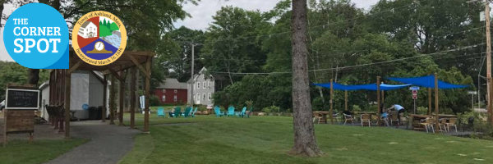
The Corner Spot Application
The Corner Spot is a “pop-up” park and storefront in downtown Ashland where businesses can test-drive the market and residents can gather. The Corner Spot is intended to stimulate economic activity, attract and support new and existing business, and make the downtown more vibrant. The Corner Spot is located at 6 Cherry Street and serves as the home for new businesses to "pop up" in the shed allowing residents to enjoy a variety of potential additions to the Ashland business community. It is a place for people to gather for a wide array of events including food, music, performers and more.
The Corner Spot offers outdoor seating, tables and chairs, a children’s play area, porch swings and a free mini library. The businesses that “pop-up” in the 300 square foot storefront have the opportunity to run their business based on their business plan and schedule to “test” out their success with the hopes of finding permanent space in Ashland. The Corner Spot serves as a resource for any business owner testing the market in a downtown setting, regardless of the business’ phase or size.

Please answer the following to apply for space in “the shed”:
I. Business Name and Description:

II. How will you successfully market your business at The Corner Spot?
List social media site(s) with your account/handle(s).
Example: Instagram @thecornerspotashland

III. Requested Dates & Hours of Operation. Please list the days of the week and hours you prefer.

IV. List your operating needs (electricity, Wi-Fi, refrigeration, etc.).

V. List the equipment you are bringing.

Additional Requirements
- Must provide your own tent and table(s) if needed
- Must comply with all permits, including Board of Health requirements, permitting, and fees
- Must clean up and lock up each day
- Everything must be removed and must be left the same way it was found.
Costs
For week long rentals of shed
- Non-refundable application fee $50 per week will be due to the Ashland Affordable Housing Trust 7 days after signing (check made payable to Ashland Affordable Housing Trust).
- $50 Utilities fee per week (check made payable to Town of Ashland)
- Refundable Security Deposit required to hold date and cover any costs of damages, $500 per week. Cancellation Fee $500 unless we can fill slot. (check made payable to Town of Ashland)
- For multiple weeks, follow this schedule for pricing:
  - $300 for 4 weeks ($25 per week discount)
  - $500 for 6 weeks (1 free week)
For 1 day, pop up:
- $25 – Must provide your own tent and tables
Please see Pop-up application.
Submit Application to Beth Reynolds at breynolds@ashlandmass.com
For questions contact Beth Reynolds at 508-532-7905

